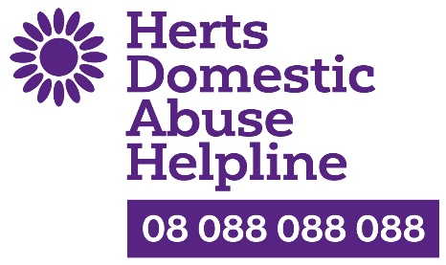

Looking for a new challenge? Interested in giving back to the community using your life experience and business skills?

Join us as an Associate Trustee progressing to a full Trusteeship

In 2022 we celebrated the 20th Anniversary of the Helpline!
We were also delighted to be awarded the Queen’s Award for Voluntary Service recognising the contribution by our many volunteers to the community in Hertfordshire.

We are looking for people to join us as Associate Trustees while they learn about the charity before progressing to a full Trusteeship in due course. People from all backgrounds are welcome to apply.

The role may suit someone who is retired, semi-retired or who works flexible hours. You will be community-oriented and have a positive/can-do attitude. You will live in Hertfordshire which is the charity’s area of operation.

Charities operate in many of the same ways as businesses so if you have worked for, or run, a business, then the skills you have acquired are valuable to our charity. We are particularly looking for people with expertise in the following areas:-

- Marketing
- Fundraising and events
- Governance – operating policies, risk assessment, compliance with Charity Commission, HSE etc.
- Social Media
- IT and data management

What you will gain
You will be volunteering with a long-established and well known countywide registered charity. And you will be joining a small but friendly Board of Trustees. You will have the opportunity to meet new people and gain satisfaction from helping to run the charity in an efficient and effective way, putting forward your ideas for future development. You will be able to take part in fundraising events and attend awareness raising events across the county. We anticipate you will be interested in volunteering in the domestic abuse field and you will receive the necessary induction and training to fill any gaps in your knowledge. There are also opportunities to attend courses on becoming a Trustee.

Your commitment
The role requires a commitment of approximately 3 hours a week. This is generally flexible and can be managed to fit the Trustee’s personal diary. It will however depend on items/projects that the charity is undertaking at any time. In addition, our Board meetings are held five times a year - either by Zoom or face to face. As well as contributing to the overall governance of the Helpline, you will have responsibility for one area (eg marketing), matched to your expertise, experience and interest. We ask for a minimum 3 year commitment and a DBS check will be undertaken. You won’t be required to deal directly with victims/survivors of domestic abuse.

About the charity
We were established in 2002 to provide a free, confidential and anonymous helpline for victims/survivors of domestic abuse who may not wish to contact the authorities for help. For many it could be the first step in moving away from an abusive relationship. We have a team of 37 well-trained call takers who work from home on a rota basis 365 days a year. We do not operate a call centre. When someone calls or emails they receive support and are signposted to the local services most appropriate to their individual situation. The caller is thus empowered to act when they are ready to do so. We do not make referrals. In 2021-22 we received 2,400 calls and emails, not only from victims/survivors but also from professionals such as GPs and social workers who have victim/survivor patients/clients. We also receive at least another 2,000 unique visitors to our website a year.

Recent and ongoing successes
- We introduced a modern cloud-based telephone service in January 2020 which provides excellent anonymised data and we added a confidential email service at Easter 2020 in response to victims/survivors being locked down with their abusers as a result of national COVID measures
- Our volunteer training has been restructured enabling us to recruit more volunteers than ever before and provide them with an excellent skills base and learning tree so they can develop their knowledge further and monitor their ongoing progress.
- We were the lead charity for the St Albans Half Marathon in June 2021
- We were the Charity of the Year for Platinum Point Business Networking Group in 2021
- We were the partner charity for the SME Herts Business Awards October 2021
- We were one of 3 local charities supported through the St Albans Fireworks event in 2021, receiving a cheque for £10,000

Learn More
To find out more about our charity, including our Vision, Mission and Values, please visit our website www.hertsdomesticabusehelpline.org

To arrange a time for an informal discussion please email Christine Roach, Chair – Chair@hertsdomesticabusehelpline.org

